**PROFESSIONAL TRAINING REPORT**

**at**

**SATHYABAMA INSTITUTE OF SCIENCE AND TECHNOLOGY**

(**Deemed To Be University**)

Submitted in partial fulfilment of the requirements for the award of

Bachelor of Engineering Degree in

Computer Science and Engineering

By

**SIGINAMSETTYSAI SUSHVANTH**

**(Reg No.38110532)**



**DEPARTMENT OF COMPUTER SCIENCE AND ENGINEERING**

**SCHOOL OF COMPUTING**

**SATHYABAMA INSTITUTE OF SCIENCE AND TECHNOLOGY**

**JEPPIAAR NAGAR, RAJIV GANDHI SALAI, CHENNAI – 600119.**

**AUGUST 2020**



**SATHYABAMA**

INSTITUTE OF SCIENCE AND TECHNOLOGY

(DEEMED TO BE UNIVERSITY)

Accredited With Grade “A” By NAAC

JEPPIAAR NAGAR, RAJIV GANDHI SALAI, CHENNAI– 600119

[www.sathyabama.ac.in](http://www.sathyabama.ac.in)

**BONAFIDE CERTIFICATE**

This is to certify that this Project Report is the bonafide work of **SIGNAMSETTY SAI SUSHVANTH(38110532)** who carried out the project entitled **“ONLINE SHOPPING CART”** under my supervision from APRIL 2020 to JUNE 2020.

Internal Guide

**Ms.USHA NANDINI. M.E,(Ph.D.,)**

**Head of the Department**

**Dr. S. VIGNESHWARI, M.E., Ph.D.,**

Submitted for Viva voce Examination held on

**Internal Examiner :** **External Examiner :**

**DECLARATION**

I, **SIGINAMSETTY SAI SUSHVANTH (REG.NO : 38110532)**Here by declare that the Professional Training Report on **“ ONLINE SHOPPING CART ”** done by me under the guidance of **Ms.USHA NANDINI M.E, (Ph.D.,)** is submitted in partial fulfilment of the requirements for the award of Bachelor of Engineering Degree in Computer Science and Engineering.

**DATE :**

**PLACE : CHENNAI SIGNATURE OF THE CANDIDATE**

**ACKNOWLEDGEMENT**

I am pleased to acknowledge my sincere thanks to **Board of Management** of **SATHYABAMA** for their kind encouragement in doing this project and for completing itsuccessfully. I am grateful to them.

I convey my thanks to **Dr.T.SasikalaM.E.,Ph.D.**,**Dean**, School of Computing, **Dr.S.Vigneshwari M.E., Ph.D., and Dr.L.Lakshmanan M.E., Ph.D.,** Heads of the Department of Computer Science and Engineering for providing me necessary support and details at the right time during the progressive reviews.

I would like to express my sincere and deep sense of gratitude to my Project Guide **Ms.USHA NANDINI M.E, (Ph.D.,)** for his valuable guidance, suggestions and constant encouragement paved way for the successful completion of my project work.

I wish to express my thanks to all Teaching and Non-teaching staff members of the **Department of Computer Science and Engineering** who were helpful in many ways for the completion of the project.

**TRAINING CERTIFICATE**



**ABSTRACT**

This project is aimed to developing an online Shopping cart web page. An online shopping system that permits a customer to submit online orders for items and/or services from a store that serves both walk-in customers and online customers. The online shopping system presents an online display of an order cut off time and an associated delivery window for items selected by the customer. The system accepts the customer's submission of a purchase order for the item in response to a time of submission being before the order cut off time. The online shopping system does not settle with a credit supplier of the customer until the item selected by the customer is picked from inventory but before it is delivered. Therefore, the customer can go online and make changes to the order. In addition, available service windows are presented to the customer as a function of customer selected order and service types and further, the order picking is assigned in accordance with a picker's preference. When ordering goods, many shopping systems provide a virtual shopping cart for holding items selected for purchase. Successive items selected for purchase are placed into the virtual shopping cart until a customer completes their shopping trip. Virtual shopping carts may be examined at any time, and their contents can be edited or deleted at the option of the customer. Once the customer decides to submit a purchase order, the customer may print the contents of the virtual shopping basket in order to obtain a hard copy record of the transaction.

**TABLE OF CONTENTS**

|  |  |  |
| --- | --- | --- |
| **CHAPTER NO** | **TITLE** | **PAGE NO** |
|  | **ABSTRACT** | V |
|  | **LIST OF FIGURES** | Viii |
|  | **LIST OF ABREVIATIONS** | ix |
| 1. | **INTRODUCTION** |  |
|  | 1.1 OUTLINE OF THE PROJECT | 1 |
| 2. | **AIM AND SCOPE OF THE PROJECT** |  |
|  | 2.1 AIM OF THE PROJECT | 2 |
|  | 2.2 PURPOSE OF THE PROJECT | 3 |
|  | 2.3 SCOPE OF THE PROJECT | 3 |
| 3. | **EXPERIMENT METHODS AND ALGORITHMS USED** |  |
|  | 3.1 REQUIRED MATERIALS | 4 |
|  | 3.2 ABOUT HTML, CSS, JAVASCRIPT | 5 |
|  | 3.2.1 Relationship Between HTML, CSS | 7 |
|  | 3.2.2 Relationship Between Html And JS | 8 |
|  | 3.3 PROPOSED SYSTEM | 9 |
|  | 3.4 USED DATABASE | 10 |
|  | 3.4.1 MONGO DB | 10 |
|  | 3.5 ADVANTAGES OF THE PROPOSED WORK | 11 |
|  | 3.6 IMPORTANCE OF WEB DESIGNING | 12 |
|  | 3.7 MODULE DESCRIPTION | 13 |
| 4. | **RESULTS AND DISCUSSION** |  |
|  | 4.1 RESULTS | 18 |
|  | 4.2 PERFORMANCE ANALYSIS | 20 |
| 5. | **SUMMARY AND CONCLUSION** |  |
|  | 5.1 SUMMARY | 21 |
|  | 5.2 CONCLUSION | 21 |
|  | 5.3 FUTURE ENHANCEMENT | 22 |
|  | **REFERENCES** | 22 |
|  | A.SOURCE CODE | 23 |
|  | B. SCREENSHOTS | 28 |

**LIST OF FIGURES**

|  |  |  |
| --- | --- | --- |
| **FIGURE No.** | **FIGURE NAME** | **PAGE No.** |
| 3.1 | WEB DEVELOPMENT | 5 |
| 3.2 | RELATION BETWEEN HTML CSS JAVASCRIPT | 7 |
| 3.3 | HTML & CSS | 8 |
| 3.4 | PROPOSED SYSTEM | 9 |
| 3.5 | MONGODB ARCHITECTURE | 11 |
| 3.6 | IMPORTANCE OF WEB DEVELOPMENT | 13 |
| 3.7 | HOME PAGE | 14 |
| 3.8 | USER MODULE | 15 |
| 3.9 | REGISTRATION | 16 |
| 3.10 | LOGIN | 16 |
| 4.1 | HOMEPAGE | 18 |
| 4.2 | LOGIN PAGE | 19 |
| 4.3 | REGESTARION PAGE | 20 |

**LIST OF ABBREVIATIONS**

|  |  |
| --- | --- |
| **ABBREVIATIONS** | **EXPANSION** |
| HTML | HYPER TEXT MARK-UP LANGUAGE |
| CSS | CASCADING STYLE SHEET |
| JS | JAVASCRIPT |
| DBMS | DATA BASE MANAGEMENT SYSTEM |
| PNG | PORTABLE NETWORK GRAPHICS |
| API | APPLICATION PROGRAMMING INTERFACE |
| IT | INFORMATION TECHNOLOGY |
| GUI | GRAPHICAL USER INTERFACE |
| SQL | STRUCTURED QUERY LANGUAGE |

**CHAPTER 1**

**INTRODUCTION**

**1.1OUTLINE OF THE PROJECT**

**Shopping Cart :**

Online shopping is a form of electronic commerce which allows consumers to directly buy goods or services from a seller over the Internet using a web browser. Consumers find a product of interest by visiting the website of the retailer directly or by searching among alternative vendors using a shopping search engine, which displays the same product's availability and pricing at different e-retailers. As of 2020, customers can shop online using a range of different computers and devices, including desktop computers, laptops, tablet computers, smart phones, and smart speakers.

An online shop evokes the physical analogy of buying products or services at a regular "bricks-and-mortar" retailer or shopping center; the process is called business-to-consumer (B2C) online shopping. When an online store is set up to enable businesses to buy from another businesses, the process is called business-to-business (B2B) online shopping. A typical online store enables the customer to browse the firm's range of products and services, view photos or images of the products, along with information about the product specifications, features and prices.

Online stores usually enable shoppers to use "search" features to find specific models, brands or items. Online customers must have access to the Internet and a valid method of payment in order to complete a transaction, such as a credit card, an Interac-enabled debit card, or a service such as PayPal. For physical products (e.g., paperback books or clothes), the e-tailer ships the products to the customer; for digital products, such as digital audio files of songs or software, the e-tailer usually sends the file to the customer over the Internet. The largest of these online retailing corporations are Alibaba, Amazon.com, and eBay.

**CHAPTER 2**

**AIM AND SCOPE OF THE PROJECT**

**2.1AIM OF THE PROJECT**

A successful site requires an effective, sustained marketing strategy beyond presenting a collection of products, services, images, videos or other files. That means your website design should be focused on specific goals, along with measurable objectives to attain them. Your marketing goals will differ depending on the nature of the work you do. For example, a primary goal for a business offering professional services to other companies might be to generate more leads. Conversely, an art or photography site might focus on attractively showcasing new work or selling it online**.**

When planning a new website, it’s understandable that you might want to jump ahead to the “fun stuff” and brainstorm ideas for advanced features. You might find yourself looking at other websites for ideas about digital bells and whistles you want to add. But features and graphics should not be your starting point you should first list your goals and objectives for the site. While increased website sales or traffic may seem to be obvious marketing goals, you’ll quickly find they’re meaningless if you don’t assess the objectives necessary to achieve the results you want.

The main aim of this project is to

* Understand the fundamentals of web page designing. Gain knowledge on HTML and CSS.
* To implement this web pages in people internet to beneficial of people.

**2.2PURPOSE OF THE PROJECT**

The main objective of the Shopping Cart System is to manage the details of Cart, Orders, Payment, Customer, Category. The purpose of the project is to build an application program to reduce the manual work for managing the Cart, Orders, Products, Payment. It tracks all the details about the Payment, Customer, Category.

It gives clear summary of the total number of items total cost, shopping fees, tax, vat, and other fees. Offers payment plans that allows customer to pay in instalments in case of high ticket products. Makes it easier for online sellers to track their customer order. This project is a web based shopping system for an existing shop. The project objective is to deliver the online shopping application into android platform. This project is an attempt to provide the advantages of online shopping to customers of a real shop.

**2.3** SCOPE OF THE PROJECT

A clear website scope allows your web design agency to finalize the cost and time frame of your website project. Scope is based on the goals of your website and needs of your users. Functionality refers to what you want your website to do (in the best part about the web designing profile is that you can choose to work in either of the IT and non-IT firms. Websites are something that will always be of utmost importance for firms that depend on digital visibility. The shopping cart project needs to create the shopping cart system to organize the products record and the other information about the customers. How customers can buy products from website can be recognized from their username and password. Scope Online shopping is rising day by day in India. Therefore, web designers are required in almost every organisation, government and private included in other words, how will the features on your website function).

**CHAPTER 3**

**EXPERIMENTAL METHODS AND ALGORITHM USED**

**3.1** REQUIRED MATERIALS

The required materials for website development are

* Atom editor
* Html
* CSS
* JavaScript
* Bootstrap

Web programming, also known as web development, is the creation of dynamic web applications. There are two broad divisions of web development – front-end development also called client-side development and back-end development also called server-side development. Front-end development refers to constructing what a user sees when they load a web application – the content, design and how you interact with it.

This is done with three codes– HTML, CSS and JavaScript. HTML, short for Hyper Text Mark up Language is a special code for ‘marking up’ text in order to turn it into a web page. Every web page on the net is written in HTML, and it will form the backbone of any web application. CSS, short for Cascading Style Sheet, is a code for setting style rules for the appearance of web pages. CSS handles the cosmetic side of the web. Finally, JavaScript is a scripting language that’s widely used to add functionality and interactivity to web pages. Back-end development controls what goes on behind the scenes of a web application. A back-end often uses a database to generate the front-end.

Among Web professionals, "Web development" usually refers to the main non-design aspects of building Web sites: writing markup and coding. Web development may use content management systems (CMS) to make content changes easier and available with basic technical skills.

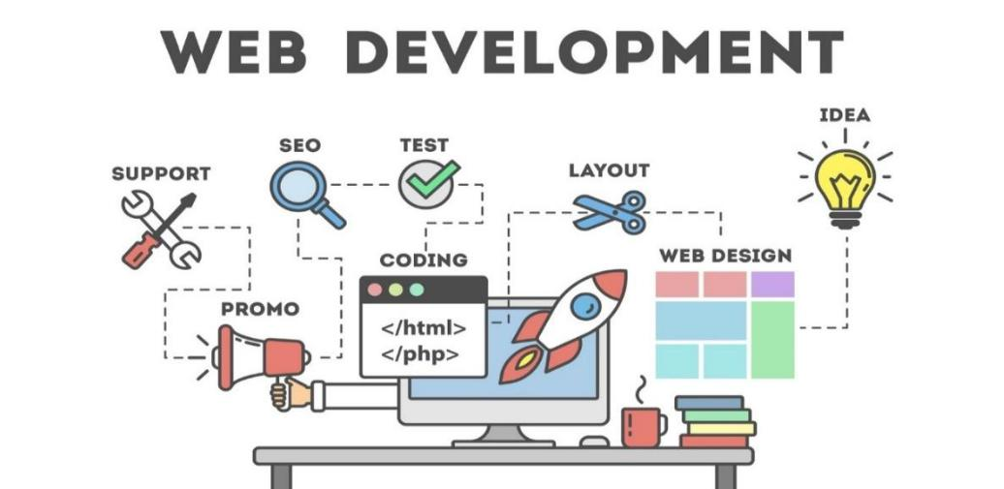

***Fig. 3.1: Web Development***

**3.2** ABOUT HTML, CSS, JAVASCRIPT

Starting with HTML which stands for Hyper Text Markup Language, by using HTML we can build website using many attributes, HTML provides various attributes which is enough for creating a basic website. It has various tags and attributes; each line starts with an opening and a closing tag which is very important in HTML. are the building blocks of HTML pages. With HTML constructs, images and other objects such as interactive forms may be embedded into the rendered page. HTML provides a means to create structured documents by denoting structural semantics for text such as headings, paragraphs, lists, links, quotes and other items. HTML elements are delineated by tags, written using angle brackets. Tags such as <img /> and <input /> directly introduce content into the page. Other tags such as <p> surround and provide information about document text and may include other tags as sub-elements. Browsers do not display the HTML tags, but use them to interpret the content of the page.

HTML can embed programs written in a scripting language such as JavaScript, which affects the behaviour and content of web pages. Inclusion of CSS defines the look and layout of content. The World Wide Web Consortium (W3C), former maintainer of the HTML and current maintainer of the CSS standards, has encouraged the use of CSS over explicit presentational HTML since 1997. It can be viewed in any web browser, HTML works with any browser along with .html or .htm extension. Recently HTML was the updated to HTML5 with new features added to it especially for audio and video. The cons with this language are, some features are not supported in every browser.

CSS stands for Cascading Style Sheet which is used to style the html page that we’ve created. Using CSS, we can make our webpage even more meaningful, it controls over the html. While CSS is great for creating text styles, it is helpful for formatting other aspects of Web page layout as well.CSS is designed to enable the separation of presentation and content, including layout, colours, and fonts. This separation can improve content accessibility, provide more flexibility and control in the specification of presentation characteristics, enable multiple web pages to share formatting by specifying the relevant CSS in a separate .CSS file which reduces complexity and repetition in the structural content as well as enabling the .CSS file to be cached to improve the page load speed between the pages that share the file and its formatting.

Separation of formatting and content also makes it feasible to present the same mark up page in different styles for different rendering methods, such as on-screen, in print, by voice (via speech-based browser or screen reader), and on Braille-based tactile devices. CSS also has rules for alternate formatting if the content is accessed on a mobile device.

The name cascading comes from the specified priority scheme to determine which style rule applies if more than one rule matches a particular element. This cascading priority scheme is predictable. For example, CSS can be used to define the cell padding of table cells, the style, thickness, and colour of a table's border, and the padding around images or other objects. More importantly, CSS enables you to do this independent of the HTML that makes up each web page.

JavaScript often shortened to JS is a lightweight, interpreted, object-oriented language with first class function, and is best known as the scripting language for Web pages, but it's [used in many non-browserenvironments](https://en.wikipedia.org/wiki/JavaScript#Uses_outside_Web_pages)as well. It is a prototype based multi-paradigm scripting language that is dynamic, and supports object-oriented, imperative, and functional programming styles. JavaScript runs on the client side of the web, which can be used to design / program how the web pages behave on the occurrence of an event. JavaScript is powerful scripting language, widely used for controlling web page behaviour. JavaScript can function as both a procedural and an object-oriented language.

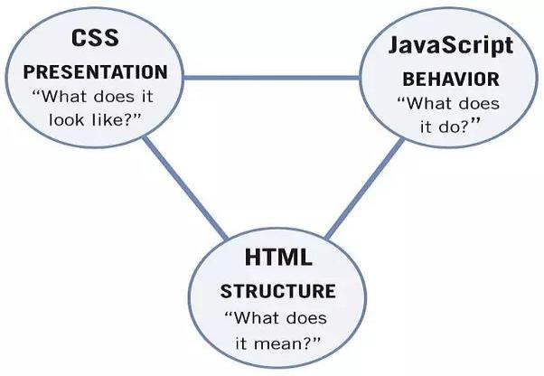

***Fig 3.2 :Relation between HTML, CSS, Java Script.***

**3.2.1 Relationship Between Html, Css.**

**HTML (Hypertext Markup Language)** is used to create the actual content of the page, such as written text, and **CSS (Cascade Styling Sheets)** is responsible for the design or style of the website, including the layout, visual effects and background colour. In 1989, Tim Berners-Lee invented the Web with HTML as its publishing language. HTML (**H**yper **T**ext **M**arkup **L**anguage) was created to help programmers describe the content on a website like <this is a heading>, <this is a paragraph>. HTML uses tags to help you add paragraphs, headers, pictures, bullets and other pieces of structure. Just like you would write something on a word document, HTML helps you write something on a website. CSS **describes** how HTML elements are to be **displayed** on screen, paper, or in other media. “CSS was first proposed by Hakom Lie and co-created by Bert Bos around 1996. Created to **compliment** HTML, CSS (**C**ascading **S**tyle **S**heets) is what makes a website look and feel amazing. Presentation and ease of use have been some of the qualities CSS has brought to web development. It is more involved with changing a websites style rather than its content. Kind of like changing the font size, font colour and positioning on a word document. CSS is in charge of the way the content looks on a page and what else goes on it to compliment that content.

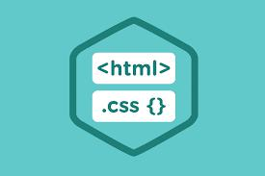

***Fig 3.3 : HTML&CSS***

**3.2.2 Relationship between HTML, JS.**

The hypertext markup programmed for a Web page is static. This means the code is displayed on the browser, and it cannot change or interact with the user's input. However, incorporating JavaScript makes a Web page dynamic. With JavaScript, a programmer can change the values and properties of an HTML tag as the user clicks a button or chooses a value from a drop-down box. JavaScript is included with the HTML code on a Web page, so it works in conjunction with the code.HTML is rendered from the server. This means that any code programmed on the Web page is processed by the server before it is sent to the user. The static code created in the HTML pages are hosted on the website's domain, and the HTML rendered can be created using dynamic programming languages such as C#, PHP or VB.NET. JavaScript is completely run on the client machine, so any

Code created is compiled and executed on the Web browser. For this reason, JavaScript is not a secure language and passwords and user names should not be processed using the JavaScript language. With several browsers on the market, compatibility is an issue for any Web application. However, HTML is consistently supported by all browsers, and the main tags used for a Web page are rendered without an issue. JavaScript functions are not always compatible across browsers. Some JavaScript functions work well in Internet Explorer, but they may not execute properly in Firefox or Chrome. For this reason, some companies are forced to list a compatibility browser for the Web application to ensure users are able to view the website properly.

**3.3.** PROPOSED SYSTEM

Our website is completely beneficial for the recovered patients who find themselves suffering with the post effects of the disease. There are many reports stating that most of the recovered patients are prone to get the disease back as their immune levels are gradually reducing over a period of time. There are certain questions designed for those patients starting from the common symptoms that 90% face after the recovery. If those mentioned symptoms are not applicable for the some of the users, then there is a separate option with voice option enabled to convey their problem more conveniently without any interruption.



***Fig 3.4 :Proposed System***

**3.4** USED DATABASE

The database that is used in this website is mongo DB. Database is very necessary for any interactive website. Designing a database is the most crucial part of development. It is necessary to be designed before the actual coding begins for a high-performance application. When a database is designed properly, only relevant data and the required information are stored. So, the data is in consistent form as the layout of the table allows the data to be consistent. Also cascading allows in data consistency.

By implementation of cascading on a parent or child Table, it will be ensured that only those child records which have valid parent record will exist. Always a good database design is normalized. Data redundancy gets reduced and duplication is removed because of normalization which ultimately leads to lessen the size of the database. Database is stored in the server computer and every time user requests; server responds with the help of the database. If the database is well designed, then the queries fired will be equally simple and its execution will be simple and fast. The overall performance will be affected by the database design. In short, the performance of the application is dependent on the design of the database. Also, it should be well-designed so that the maintenance is easy. This is the most important issue amongst all. So, there are many benefits of a well-planned and designed database. Before starting with the coding part of an application spending a good time with the designing of the database is a good practice.

**3.4.1 Mongo DB**

Mongo DB is a document-oriented No SQL database used for high volume data storage. Instead of using tables and rows as in the traditional relational databases, Mongo DB makes use of collections and documents. Documents consist of key-value pairs which are the basic unit of data in Mongo DB. Collections contain sets of documents and function which is the equivalent of relational database tables.

FEATURES OF MONGO DB:

1. Each database contains collections which in turn contains documents. Each document can be different with a varying number of fields. The size and content of each document can be different from each other.
2. The document structure is more in line with how developers construct their classes and objects in their respective programming languages. Developers will often say that their classes are not rows and columns but have a clear structure with key-value pairs.
3. The rows (or documents as called in Mongo DB) doesn't need to have a schema defined beforehand. Instead, the fields can be created on the fly. The data model available within Mongo DB allows you to represent hierarchical relationships, to store arrays, and other more complex structures more easily.

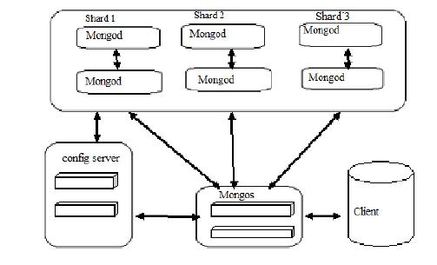

***Fig 3.5 : MONGODB ARCHITECTURE***

**3.5** ADVANTAGES OF PROPOSED SYSTEM

Online surveys save a lot of time and effort. Through an online feedback management system, you can quickly create, administer, collect and analyse surveys. Performing all of these functions in one integrated web system saves you a considerable amount of time. It is very easy and convenient for respondents to complete surveys online. Participants can fill out questionnaires when they choose to and start and stop a survey at their leisure. This gives control over completing the survey to the individual, which can increase engagement and response rates. Administering your surveys through an online system increases accessibility. We can send a link to the survey via email and set-up subsequent reminders through the online feedback management system. Respondents then have a variety of ways to access the questionnaire including mobile devices, tablets, laptops, desktop computers, etc.

3.6 IMPORTANCE OF WEB DESIGNING

Our website design is important because our customers care about design. Whether consciously or not, we all react to visuals, and people are naturally drawn to good design. When it comes to your website design, studies have shown again and again that users quickly judge your business based on visuals alone, and will often stop Using your site if it’s poorly designed. “88% of online visitors/ consumers are less likely to return to a site after a Bad experience.”

This means that your website has to not only create a great first impression by being easy to read, easy to navigate and appealing aesthetically, it also has to entice visitors to stay on your site by almost immediately answering the questions. Responsive web design simply means making websites that can adapt to the size of the visitor's viewport. The goal is for content to render differently depending on the device or screen size so that visitors have an optimal experience no matter how they access a website. The primarily benefit of responsive web design is that sites load quickly without any distortions, so users don't need to manually resize anything to view content. First impressions are everything, so whether someone is visiting a website for the first time from their desktop or their smart phone, you want them to have a consistently positive experience. If visitors must do a lot of zooming, shrinking and pinching their screens during their first visit, they're likely to give up and try another website.

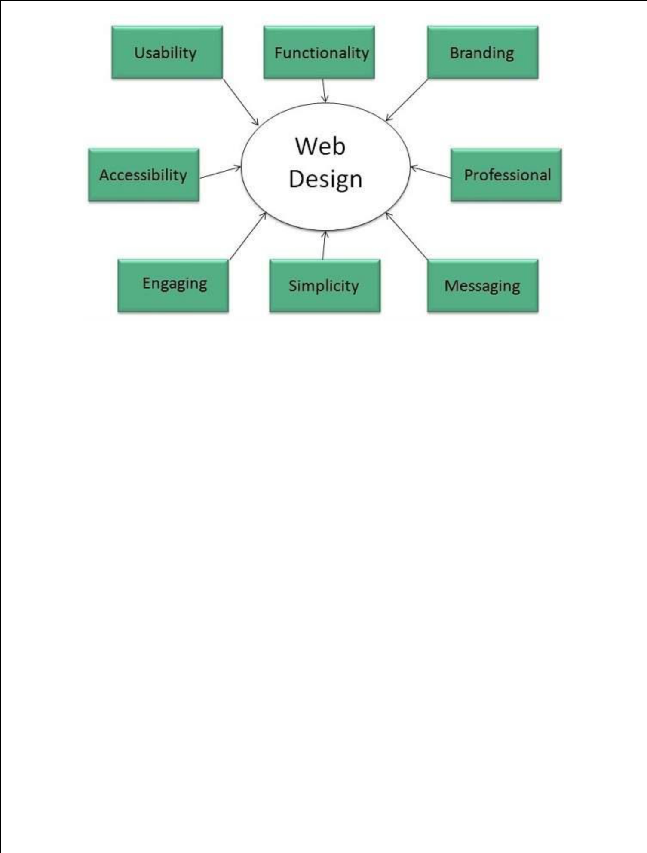

***Fig 3.6: IMPORTANCE OF WEB DESIGNING***

It’s highly recommended or rather virtually mandatory to have an optimized responsive website. This way all users will be able to navigate through it regardless of the operating system they are using. Any respectable company must have a quality corporate website. It will help in developing an application later on. If you conceive your app as a web application, strive to have a decent portal on the Internet. Web apps are possibly not the most efficient and recommended design available but everything will depend on which goal you want to achieve with it. Like with all kinds of applications, a web app has its advantages and disadvantages. This kind of application can be a quick and easy solution if you just want to establish a direct link to your website. We consider that developing an interpreted app is necessary if you want to go further. In any case, [web app](https://en.yeeply.com/blog/get-involved-web-app-development/) [development](https://en.yeeply.com/blog/get-involved-web-app-development/) has its positive and negative side. Let’s start with its advantages and later go on to see its disadvantages. Subsequently, it should be you who decides what suits your needs or preferences best.

**3.7 MODULE DESCRPTION**

By using HTML, CSS I have created this web page. This web page is titled as “online shopping cart”. This web page is useful for shopping and reduce our time and by these web pages we can gain some knowledge how to use modern technology. Implementation of the system using CSS and HTML in front end with javascript as back end and it will be used for database connectivity. And the databasepart is developed by mysql. Responsive web designing is used for makingthe website compatible for any type of screen. In this project i have created background colouring by using CSS module. In this project i created login page and registration page. If we don’t have account in this we can create a new account with the help of new user. If we already having an account in this by click on login we can enter into our account we can order and we can get delivery.

Home page consist of different html pages home page is base page for all web pages which were created in that shopping cart web page the home page is consist as shown in the fig- 3.7 below . In this home page by using carousel technique we added photos that means the photos will automatically will role from left to right and right to left. And home page is base page for our project.

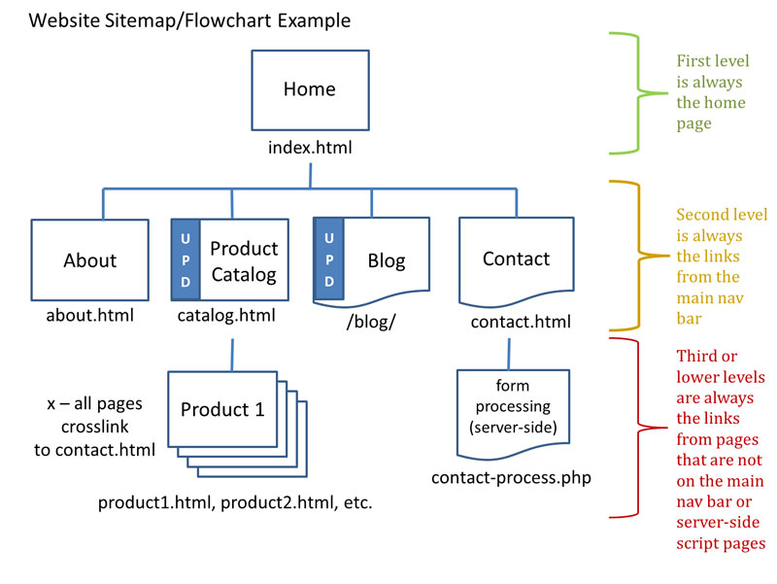

***Fig 3.7 : HOMEPAGE***

User can see the product by some images and if he like those he can place an order and he can search different product styles like in case of men (casual wear, shorts, jeans etc.,). User having a source he can edit his profile at any time. A home page is generally the main web page a visitor navigating to a website from a search engine will see, and it may also serve as a landing page to attract visitors. The home page is used to facilitate navigation to other pages on the site by providing links to prioritized and recent articles and pages, and possibly a search box. For example, a news website may present headlines and first paragraphs of top stories, with links to full articles. Meanwhile, other websites use the home page to attract users to create an account. Once they are logged in, the home page may be redirected to their profile page. This may in turn be referred to as the "personal home page".

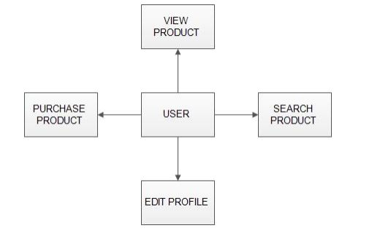

***Fig 3.8 : USER MODULE***

If user does not having an account he can create an account by using registration or new user. To A new user will have to register in the system by providing essentialdetails in order to view the products in the system. The admin must accept new user by unblocking him. If user having an account he can login into his account by giving the details which they provided in the box.

After giving those details he can login into his account and user can do anything as shown in Fig 3.8.Registration necessarily provides more personal information to a system than it would otherwise have. Even if the credentials used are otherwise meaningless, the system can distinguish a logged-in user from other users and might use this property to store a history of users' actions or activity, possibly without their knowledge or consent. While many systems have privacy policies, depending on the nature of the system, a user might not have any way of knowing for certain exactly what information is stored, how it is used, and with whom, if anyone, it is shared.

The required details for registration are Firstname, lastname, username, email id, password after giving those details we can create an new user account after creating an account by giving the email id and password which he provided in the register form by using those information he can login into his account.

**REGISTRATION**

**PASSWORD**

**EMAIL**

**USER NAME**

**LAST NAME**

**FIRST NAME**

***Fig 3.9 : REGISTRATION***

LOGIN

USER EMAIL

PASSWORD

***Fig3.10 : LOGIN***

By using CSS coding for home page and login and registration page we created background.

and in home page we created the setup for each gender and we can separate the clothes by clicking on filters we can add our needs in those filters after filtering it shows the output as we need. The user can add the desired product into his cart by clicking add to cart option on the product. He can view his cart by clicking on the cart button. All products added by cart can be viewed in the cart. User can remove an item from the cart by clicking remove. Logging in is usually used to enter a specific page, website or application, which trespassers cannot see. Once the user is logged in, the login token may be used to track what actions the user has taken while connected to the site. Logging out may be performed explicitly by the user taking some actions, such as entering the appropriate command or clicking a website link label as such. It can also be done implicitly, such as by the user powering off his or her workstation, closing a web browser window, leaving a website, or not refreshing a website within a defined period.

After confirming the items in the cart the user can submit the cart by providing a delivery address. On successful submitting the cart will become empty. Logging out of a computer, when leaving it, is a common security practice preventing unauthorised users from tampering with it. There are also people who choose to have a password-protected screensaver set to activate after some period of inactivity, thereby requiring the user to re-enter his or her login credentials to unlock the screensaver and gain access to the system. There can be different methods of logging in that may be via image, fingerprints, eye scan, password (oral or textual input), etc

**CHAPTER 4**

**RESULTS AND DISCUSSIONS**

**4.1** RESULTS

The application can be used for any Ecommerce application. It is easy to use, since it uses the GUI provided in the user dialog. User friendly screens are provided. The application is easy to use and interactive making online shopping a recreational activity for users. It has been thoroughly tested and implemented. The fig 4.1 which is inserted below is the result of my home page to run this home page our system should have goggle chrome, or internet explorer. If we have any one software in this we can see our output.



***Fig 4.1 : HOME PAGE OUTPUT***

To get into login page we need to click on login button on home page which is at the right side of our page then we can get into login page. As shown in the fig 4.2 we will get output.

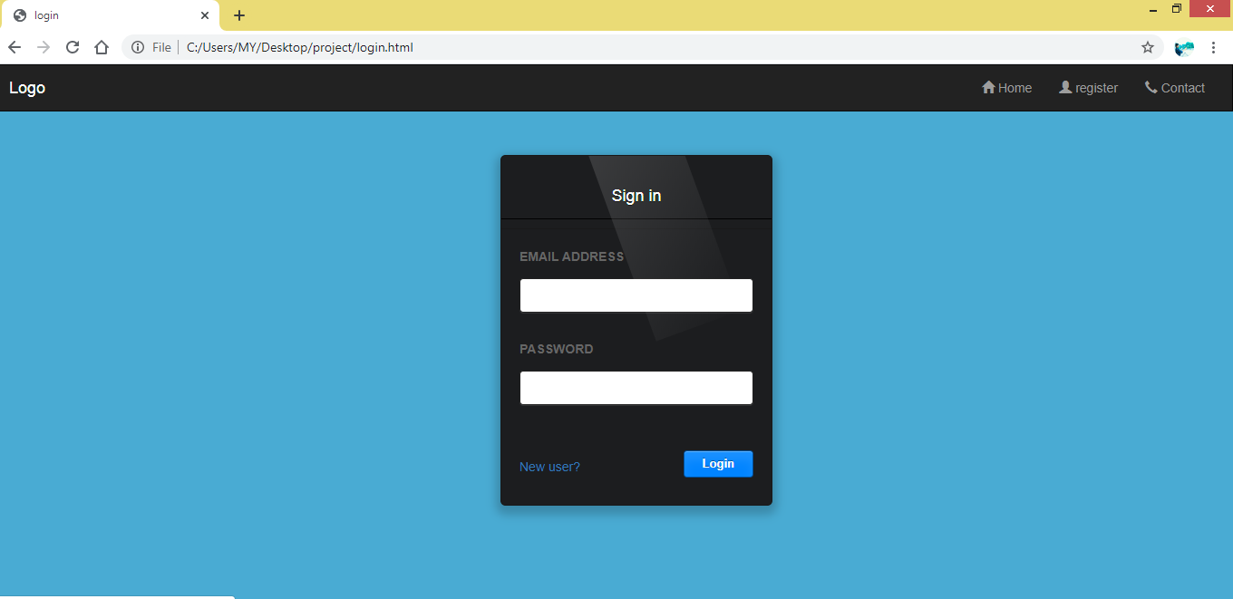

***Fig 4.2 : LOGIN PAGE***

To get into registration page we should click on the register which is present in the right corner of login page or we can click on new user which is present under the password. Then it will take to the registration page. As shown in fig 4.3 we will get output.

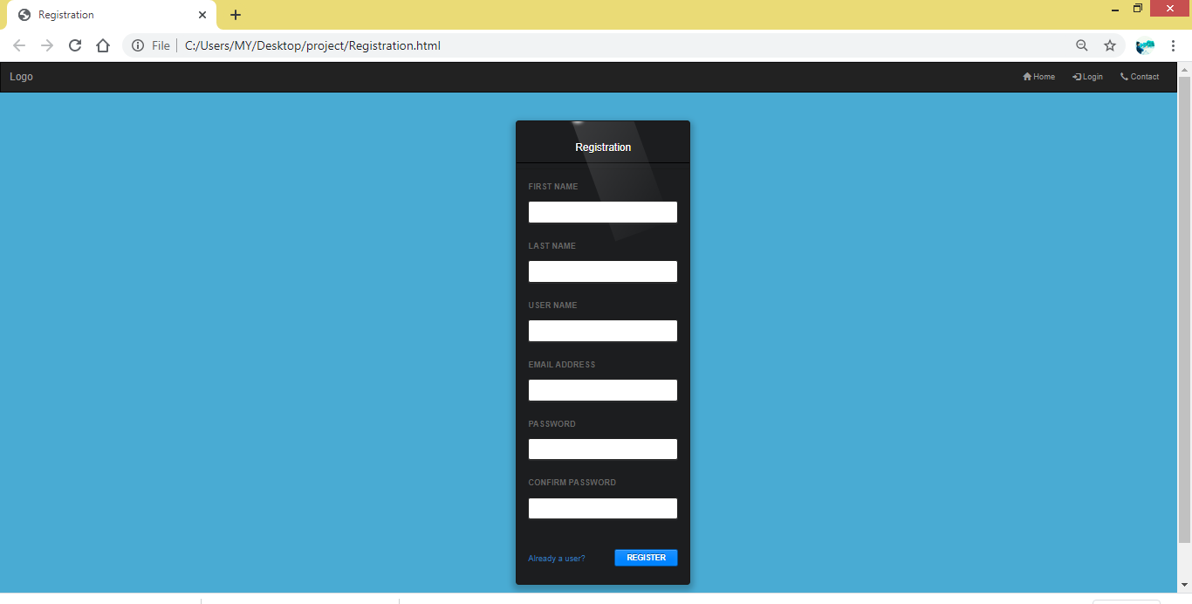

***Fig 4.3 : REGISTRATION PAGE***

**4.2** PERFORMANCE ANALYSIS

There are many types of surveys available these days through offline and online. But when we compare the performance analysis of these two surveys, online survey will be more beneficial because of its various advantages such as time, cost, efficiency. These options are not available when it comes to the traditional methods. The methods are also tough starting from taking the survey to collecting the data which is tough to organize. But in online surveys the data is directly stored in the database which is easy to locate.

So accordingto the performance analysis online surveys are very much better than the traditional methods.

**CHAPTER 5**

**SUMMARY AND CONCLUSION**

**5.1** SUMMARY

A user must login with his user name and password to the system after registration. User can view the list ofproducts based on their names after successful login…. The user can add the desired product into his cart byclicking add to cart option on the product. He can view his cart by clicking on the cart button.

**5.2** CONCLUSION

After having a detail study on online shopping. We can see a great change in the behavior of people in many mananers like their attitude buying pattern. In earlier timespeople use to do manual shopping but now as time changed,people are becoming busys and due to which technology has brought a new revolution i.e., online shopping.

As we started doing survey.it come to in notice that young age group people i.e. 15-30 uses of prefer online shopping because it is time and energysaving. But middle age group does not prefer much because they have wrong perception that by seeing the product one can get the goods of proper quality.And even some people does not prefer using plastic money i.e. credit cards.

* From the project I conclude that the web page created using html, css, JavaScript for shopping cart easier.
* This project has really been faithful and informative.
* It has made us learn and understand the many trivial concepts of HTML,CSS,JAVASCRIPT.

**5.3** FUTURE ENHANCEMENT

1. Want to increase facilities of this project.
2. Want to develop graphic design.
3. Want to remove the limitations.
4. Want to publish this website in online.
5. Want to provide personalized inbox to the user

**REFERENCES**

* <https://money.howstuffworks.com/business-communications/how-online-surveys-work.htm>
* <https://www.elinsys.com/blog/the-importance-of-database-design-in-web-designing/#:~:text=%E2%80%93%20When%20a%20database%20is%20designed,cascading%20allows%20in%20data%20consistency.>
* [https://www.techopedia.com/definition/27866/online-survey#:~:text=An%20online%20survey%20is%20a,statistical%20software%20to%20provide%20analytics](https://www.techopedia.com/definition/27866/online-survey#:~:text=An%20online%20survey%20is%20a,statistical%20software%20to%20provide%20analytics.).
* <https://www.cvent.com/en/blog/events/advantages-disadvantages-online-surveys>
* <https://www.guru99.com/what-is-mongodb.html>

**APPENDIX**

1. **SOURCE CODE**

**Index: HOME PAGE :**

<!DOCTYPE html>

<html lang="en">

<head>

<title>S-Kart</title>

<meta charset="utf-8">

<meta name="viewport" content="width=device-width, initial-scale=1">

<link rel="stylesheet" href="https://maxcdn.bootstrapcdn.com/bootstrap/3.4.1/css/bootstrap.min.css"><script src="https://ajax.googleapis.com/ajax/libs/jquery/3.4.1/jquery.min.js"></script>

<script src="https://maxcdn.bootstrapcdn.com/bootstrap/3.4.1/js/bootstrap.min.js"></script>

<style>

.navbar {

margin-bottom: 0;

border-radius: 0;

}

footer {

background-color: #f2f2f2;

padding: 25px;

}

.carousel-inner img {

width: 100%;

margin: auto;

min-height:200px;

}

@media (max-width: 600px) {

.carousel-caption {

display: none;

}

}

</style>

</head>

<body style="background-color:#49abd3;">

<nav class="navbarnavbar-inverse">

<div class="container-fluid">

<div class="navbar-header">

<button type="button" class="navbar-toggle" data-toggle="collapse" data-target="#myNavbar">

<span class="icon-bar"></span>

<span class="icon-bar"></span>

<span class="icon-bar"></span>

</button>

<a class="navbar-brand" href="#">Logo</a>

</div>

<div class="collapse navbar-collapse" id="myNavbar"><ul class="navnavbar-nav">

<li><a href="home.html"><span class="glyphiconglyphicon-home"></span> Home</a></li><li><a href="1.jpg"><span class="glyphiconglyphicon-gift"></span> Deals</a></li>

<li><a href="3.png"><span class="glyphiconglyphicon-shopping-cart"></span> Cart</a></li></ul>

<ul class="navnavbar-navnavbar-right">

<li><a href="#"><input type="text" placeholder="Search"><span class="glyphiconglyphicon-search"></span></a></li>

<li><a href="login.html"><span class="glyphiconglyphicon-log-in"></span> Login</a></li>

<li><a href="contact.html"><span class="glyphiconglyphicon-earphone"></span> Contact</a></li>

</ul>

</div>

</div>

</nav>

<div id="myCarousel" class="carousel slide" data-ride="carousel"><ol class="carousel-indicators">

<li data-target="#myCarousel" data-slide-to="0" class="active"></li><li data-target="#myCarousel" data-slide-to="1"></li><li data-target="#myCarousel" data-slide-to="2"></li>

</ol>

<div class="carousel-inner" role="listbox">

<div class="item active">

<imgsrc="1.jpg" alt="Image">

<div class="carousel-caption">

</div>

</div>

<div class="item">

<imgsrc="2.jpg" alt="Image">

<div class="carousel-caption">

</div>

</div>

<div class="item">

<imgsrc="3.png" alt="Image">

<div class="carousel-caption">

</div>

</div>

</div>

<a class="left carousel-control" href="#myCarousel" role="button" data-slide="prev"><span class="glyphiconglyphicon-chevron-left" aria-hidden="true"></span><span class="sr-only">Previous</span>

</a>

<a class="right carousel-control" href="#myCarousel" role="button" data-slide="next"><span class="glyphiconglyphicon-chevron-right" aria-hidden="true"></span><span class="sr-only">Next</span>

</a>

</div>

<div class="container text-center">

<h3>CATEGORIES</h3><br>

<div class="row">

<div class="col-sm-4">

<p><a href="men.html">

<imgsrc="456.png" alt="Girl in a jacket" style="width:300px;height:300px;"></a>

<h5 style="text-align:center";<b>MEN'S FASHION </b></h5>

</p>

</div>

<div class="col-sm-4">

<p><a href="women.html">

<imgsrc="456.png" alt="Girl in a jacket" style="width:300px;height:300px;"></a>

<h5 style="text-align:center";<b>WOMEN'S FASHION </b></h5>

</p>

</div>

<div class="col-sm-4">

<p><a href="kid.html">

<imgsrc="456.png" alt="Girl in a jacket" style="width:300px;height:300px;"></a>

<h5 style="text-align:center";<b>KID'S FASHION </b></h5>

</p>

</div>

<div class="col-sm-4">

<p><a href="app.html">

<imgsrc="456.png" alt="Girl in a jacket" style="width:300px;height:300px;"></a>

<h5 style="text-align:center";<b>APPLIANCE </b></h5>

</p>

</div>

<div class="col-sm-4">

<p><a href="ele.html">

<imgsrc="456.png" alt="Girl in a jacket" style="width:300px;height:300px;"></a>

<h5 style="text-align:center";<b>ELECTRONICS </b></h5>

</p>

</div>

<div class="col-sm-4">

<p><a href="haf.html">

<imgsrc="456.png" alt="Girl in a jacket" style="width:300px;height:300px;"></a>

<h5 style="text-align:center";<b>HOME AND FURNITURE </b></h5>

</p>

</div>

</div>

</div><br>

<footer class="container-fluid text-center">

<a href="home.html">Back to top</a>

</footer>

</body>

</html

**B. SCREENSHOTS**

**HOME PAGE OUTPUT**



**LOGIN OUTPUT :**

If we go and click on that login button as shown in 5.2.1 and we will get an output as shown in 5.2.2



5.2.1

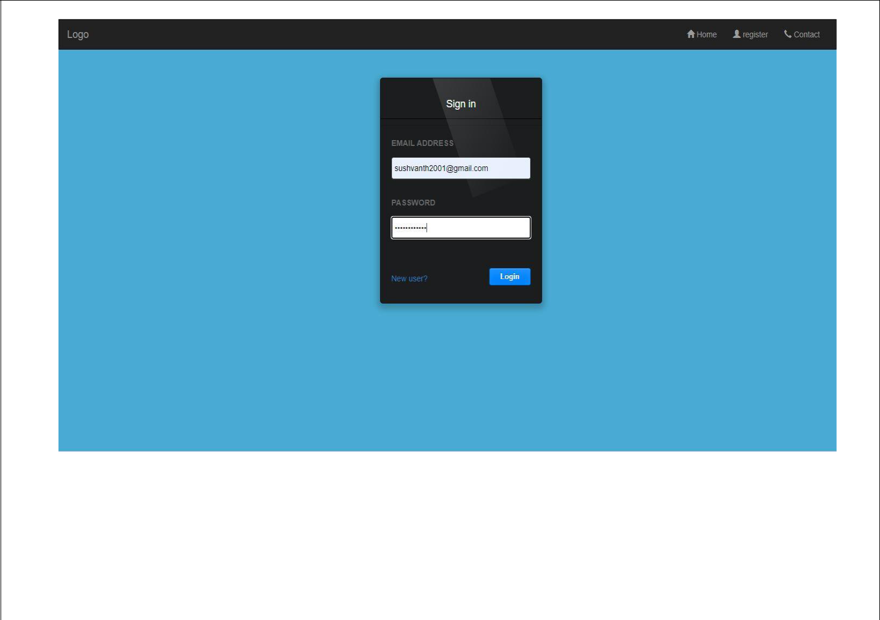

5.2.2

**REGISTRATION OUTPUT :**

If we go on and click on New User / Registration as shown in 5.3.1 we will get an output as shown in5.3.2



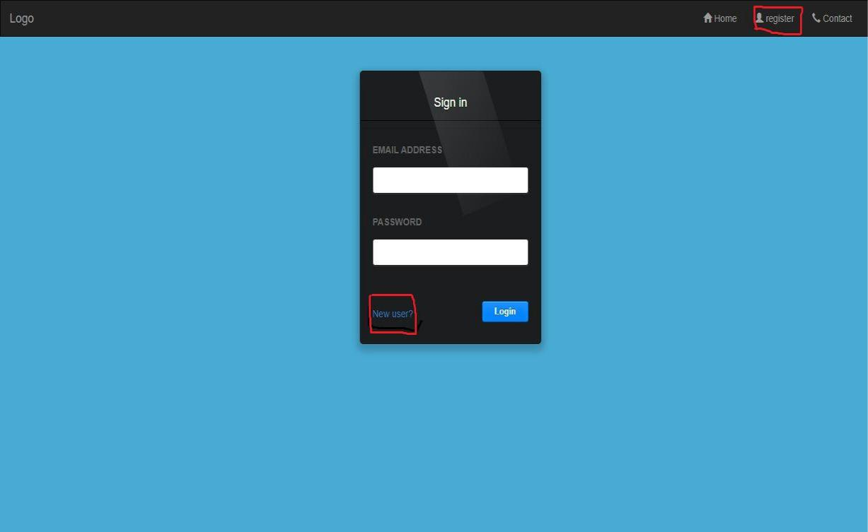

5.3.1

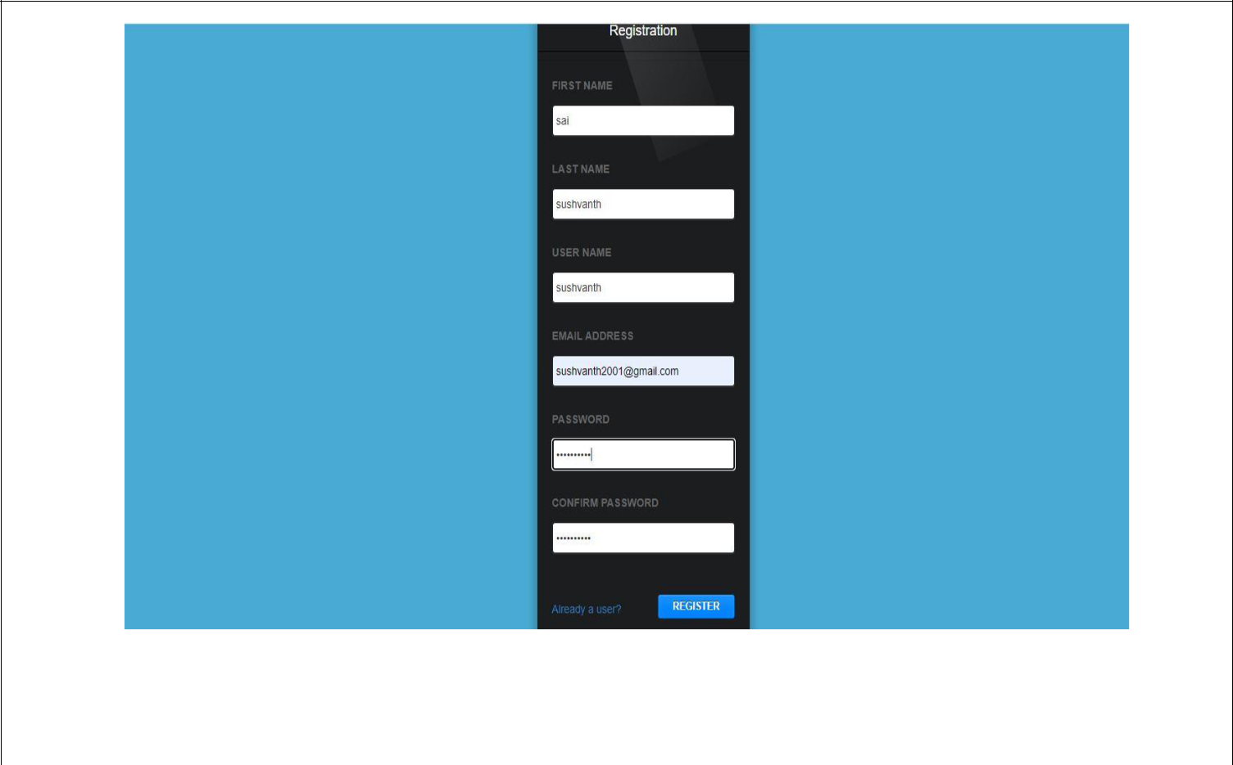

5.3.2